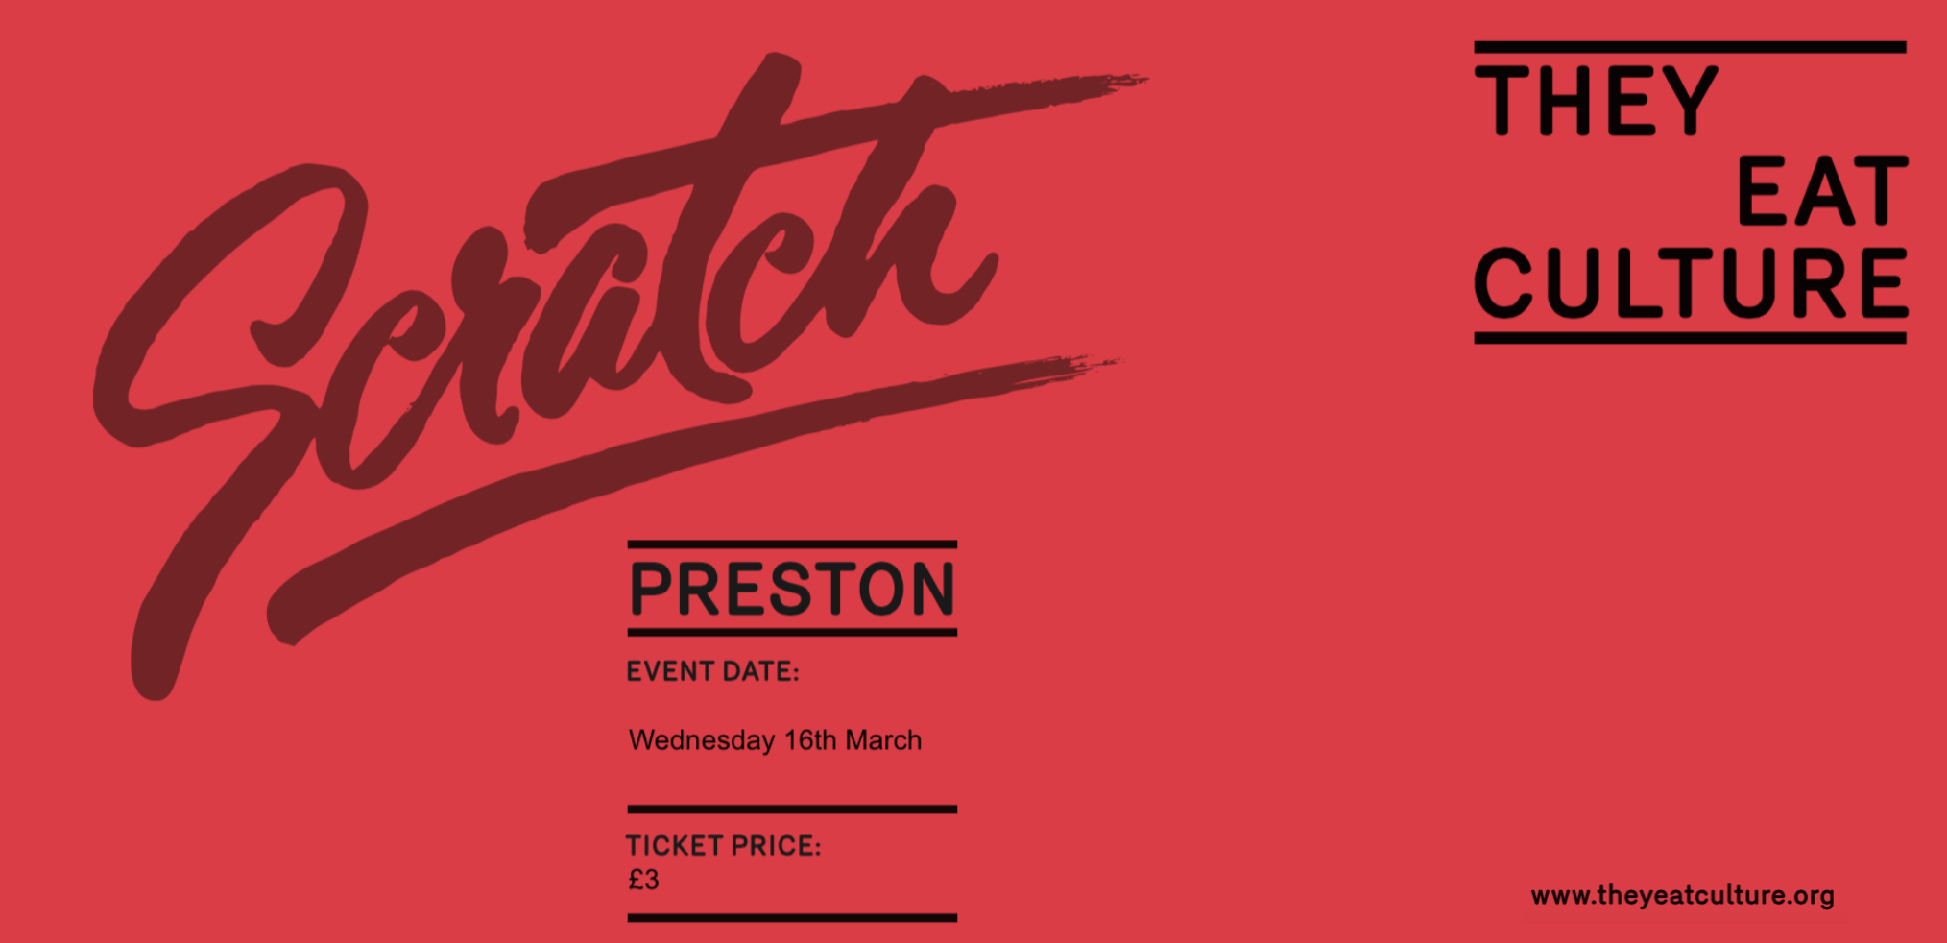
WHAT IS SCRATCH?
They Eat Culture present Scratch Preston, a monthly informal showcase for new
performance projects and ideas. This platform is open to artists from all disciplines at any stage of their career. This might include; live-art, performance, dance, spoken word, film etc…

Scratch Preston is for new ideas, to show works in progress or projects in
development. It is not a place to present pre-existing work, don't present a snippet of a performance you already have.

Each scratch should be no longer than 10 minutes, we will programme 4/5 scratches per evening. After the performances there will be the opportunity for audience
members and artists to share feedback, allowing response and development
conversations.

There will be a short break between each scratch allowing time for the turn arounds and for audience members to get drink form the bar and discuss work they have seen.
WHAT YOU NEED TO KNOW…
Event Date: Wednesday 16th March 2016 7.30pm
Submission Deadline; Sunday 28th February 2016 - Midnight.
Venue/Technical information

Scratch Preston will take place in the events space at;
The Continental,
South Meadow Lane,
Preston,
Lancashire,
PR1 8JP

The venue space will be set up to provide basic technical requirements.
We can provide;
- A warm wash, general lighting state.
- A PA system for audio playback and microphones.

If you have additional technical requirements please specify them in your proposal.
Artists are required to provide sound files/music and cue sheets at least 3 days prior to Scratch Preston. Technical time - Each artist will have 30 minutes of tech time in the event space on the day of Scratch Preston.
Marketing & Documentation

Each artist/company will need to provide a copy (100 words max) and a promotional image, this will be used on our website and social media.

We will document each scratch and send the film/photos to each artist.
Box Office

Tickets for Scratch Preston are £3. This helps us cover the costs of our technical operator and documenter.

Tickets can be booked over the phone, online or on the door.

Scratch Preston cannot offer any complimentary tickets. Only artists performing on the night will get in for free.
About They Eat Culture and how we can support you.

They Eat Culture is a direct creative intervention into the cultural life of Preston and
Lancashire. We programme, commission, & produce quality arts & cultural work, and run
culturally engaging, in-deep projects co-designed with communities.

Our aim with Scratch Preston, is to create a space for artists to share new ideas and invite an audience to experience works in progress, discuss ideas and provide feedback.
Scratch Preston is an opportunity for artists to test their ideas and see what works and what doesn't work, it allows artists to think about development, and what the next stage might be.

Before the event we will arrange an informal supper for our Scratch Preston artists, and invite a handful of people working in the arts, from across a range of creative/production backgrounds, who can give artists information/tips and guidance, and answer your questions on your next steps. We’ll send you a list of who’ll be there about a week before the scratch night.
APPLICATION FORM
Please complete the form as accurately and detailed as possible.

The application will need to be completed and returned by Midnight on
Sunday 28th February 2016, along with supporting documentation and media.

Please submit the application to charlotte@theyeatculture.org
Name:
Company Name:
Title of Performance:
Number of Performers:
Contact Number:
Email:
Website:
Tell us a bit about your arts practice (no more than 200 words)
Tell us about the work you would like to share at Scratch Preston. (no more than 200 words)
Marketing Copy (100 words max)
Additions technical Requirements (These should be basic)
Other Requirements.
What will you provide?
Additional information (health and safety, age restrictions, hazards etc):
Anything else you wish to tell us?
Completed proposals should be sent along with attached promotional images to charlotte@theyeatculture.org

Please include name of artist/company on the filename attachments.

All applications need to be received by Midnight of Sunday 28th February 2016.

If you have any questions about Scratch Preston and the proposal please contact Charlotte Berry via email. - charlotte@theyeatculture.org

